

**Library Management System**

**Design Document**

Elsayed ehab elsayed mohamed

Ahmed gamal fawzy nagy

Anas mahmoud gamal

Mohamed ali ali eltemamy

Mostafa ahmed farahat

# 

# 

# 

# SYSTEM ARCHITECTURE

The Library Management System has been designed for Librarians to carry out various services in a library. Each functionality has been explained as follows:

1. Log-in:

It allows only the library members to access the system with their username and password, it is connected with a table in the database with the members usernames

1. Add user:

It is connected with a table in the database which allows you to add members to the library system with their username and password.

1. All available books:

This button displays all the available books (Excluding the borrowed) to the user, it is connected to the books table in the database. This table contains all the detailed information about all the books in the library.

1. Search for a book:

You can search for a book in multiple ways (by name – by author – by published year – by category), it is connected to the books table.

1. Borrowed books:

This button displays all the borrowed books, it is constantly changing depending on the borrowed and retrieved books. It is connected to the borrowed books table in the database. This table contains all the detailed information about all the borrowed books in the library and the borrower information (name,e-mail,or phone No.)

1. Borrow a book:

This button allows the borrowers to choose a book from the library and enter their e-mail or phone number so they will be able to borrow the book, it is connected to a table in the data base which contains all the borrowed books, and the borrowed books will be temporarily removed from the books table util retrieving the book.

1. Add or delete a book

This button allows the members to add new book with its information to the library and it will be directly added to the table in the database or the opposite (delete a book).

# DESIGN DECISIONS/ASSUMPTIONS

1. There is only one copy of each book that exists in the library
2. Only book ID has been considered in the entire processing

# LANGUAGES/IDE USED

1. Java Swing
2. Eclipse IDE
3. MySQL Server
4. MySQL Workbench
5. Windows 11

# REQUIREMENTS TO RUN THE APPLICATION

1. MySQL running on a localhost
2. Java SE platform
3. JDK installed

# Why e-library?

It aims to help the universities and schools’ students and others to a wide variety of content access, it offers the latest edition of books accessible to the readers, It make Readers Find Resources Instantly, The library management software comes with built-in features to automate library management, and finally you can access the books 24/7.

# ERD Diagram

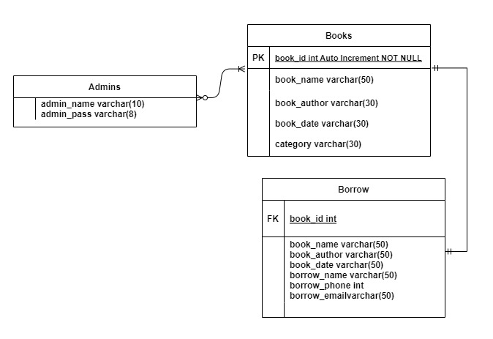

# MAP Diagram

